org

Perimeta 365 – Hybrid Exchange

Implementation Plan

Date 2 August 2021

Document Information

Document Acceptance for v1.0
Function | Date | Name | Position
Prepared: | 02-08-2021 |  | Senior Consultant
Reviewed: | 02-08-2021 |  | Senior Consultant
Released: | 02-08-2021 |  | Senior Consultant

Drafting and Release History
Version | Date | Author | Description
1.0 | 02-08-2021 | Col McKeahnie | Release to AGENCY

oobe contact details | oobe Pty Ltd
oobe contact details | | www.oobe.com.au  | GPO 111 Canberra City 2601  | ACN 123 977 846  | ABN 48 123 977 846

Contents
Introduction 4
Project Overview 4
Purpose 4
Scope 4
Implementation 5
Overview 5
Steps 5
Connectivity 6
Abbreviations and Acronyms 12

Introduction

Project Overview
- The Org has engaged oobe Pty Ltd (oobe PL) to configure their Microsoft 365 (M365) tenant, leveraging oobe’s Perimeta for 365 (P365) product. This project involves the preparation and onboarding of the AGENCY Azure tenant to P365, the synchronisation of identities, automated configuration of the tenant by P365, migration of mailboxes, and the build of Windows 10 devices.

Purpose
- The purpose of this implementation plan is to document the requirement and process to complete the configuration of Exchange Online in a hybrid configuration with AGENCY’s existing on-premises Exchange infrastructure.

Scope
- The configuration of the following components are in scope of this implementation plan:
- Updating mail records,
- Mail flow between Exchange Online and Exchange on-premises,
- Mailbox migration, and
- Post migration support tasks.

Implementation

Overview
- The Implementation of Hybrid Exchange connectivity for the AGENCY requires updates to existing on-premises gateway and mail delivery infrastructure to facilitate mail flow and migration of mailboxes between on-premises Exchange mail servers and the AGENCY Microsoft 365 tenant.
- This document will outline the steps and connectivity requirements to achieve Simple Mail Transfer Protocol (SMTP) mail flow for the AGENCY Exchange Hybrid Deployment to facilitate migration of on-premises mailboxes to Exchange Online.

Steps
- Table 1 below outlines the high-level Implementation activities required to support the AGENCY Hybrid Exchange Migration:
Table 1 | Implementation Plan Execution Steps
Item | Implementation Plan Description | Responsibility
Azure Active Directory (Azure AD) Hybrid Connectivity | - Implement an on-premises Azure AD Connect server and synchronise identities to from on-premises Active Directory (AD) to Azure AD. | oobe
Exchange Hybrid Agent Configuration | - Implement and configure Exchange Modern Hybrid Agent on-premises. | oobe
Mail Exchanger (MX) record, Sender Policy Framework (SPF), Domain-based Message Authentication, Reporting and Conformance (DMARC), DomainKeys Identified Mail (DKIM), Domain Name System (DNS) for all components | - Update SPF record to include protection.outlook.com -all | AGENCY (oobe to advise)
Configure Exchange Hybrid Mail flow | - Allocate an internal IP address for a failover virtual IP (VIP) hosted on the on-premises Fortinet device for the inbound SMTP traffic.  - Configure the SMTP failover VIP.  - Allocate a public IP address that will be translated (using Network Address Translation (NAT)) to SMTP failover VIP IP address.  - Assign public DNS record to public IP address.  - Assign a certificate to the public IP / DNS record.  - Inbound Firewall Rule configuration.  - Outbound Firewall Rule Configuration. | AGENCY (oobe to advise)
Perform Mailbox Migration to Exchange Online | - Assign mailbox batches for migration and execute. | Joint (AGENCY and oobe)
Post Migration Support Tasks | - Testing / validation of migrated mailboxes and users  - Re-configuration of Hybrid Exchange to Exchange Online only*  Note: Confirmation of requirement to move from hybrid exchange configuration to exchange online only TBC. | Joint (AGENCY and oobe)

Connectivity
- Table 2 below outlines network connectivity and proxy requirements to support the AGENCY Hybrid Exchange migration:
Table 2 | Network Connectivity
Purpose | Source | Destination | Port
Exchange Hybrid | Hybrid Exchange Servers – On Premise (Exchange 2016) | *.msftauth.net  *.msftauthimages.net  *.phonefactor.net  crl.microsoft.com  enterpriseregistration.windows.net  login.microsoftonline.com  login.windows.net  management.azure.com  mscrl.microsoft.com  nexus.microsoftonline-p.com  ocsp.msocsp.com  policykeyservice.dc.ad.msft.net  watchdog.servicebus.windows.net  *.store.core.windows.net  asl.configure.office.com  mshrcstorageprod.blob.core.windows.net  tds.configure.office.com  mshybridservice.trafficmanager.net  domains.live.com  r1.res.office365.com  r3.res.office365.com  r4.res.office365.com  *.outlook.com  *.outlook.office.com  attachments.office.net | 80/443

- Table 3 below outlines the required name resolution records or TXT entries required for verified domains:
Table 3 | Name Resolution Records or Text Entries for Verified Domains
Purpose | Record | Destination | TTL
Exchange | A record for inbound STMP from Exchange Online Protection (EOP) | hybrid.AGENCY.gov.au – point to public IP that NATs to on-premises Exchange Transport Roles.
 | Mail Exchanger (MX) | N/A – Use existing MX records until full migration to Exchange Online has been completed | 60 min
 | SPF: AGENCY.gov.au (TXT Record) | v=spf1 mx  include: spf.protection.outlook.com -all | 60 min
 | CNAME: | N/A - To be configured once full migration to exchange Online has been completed | 60 min
Domains | AGENCY.gov.au | Already exists

- Table 4 and Table 5 list the public NAT/Virtual IP (VIP) for inbound communications required for the Hybrid Exchange inbound SMTP Modern Agent.

- Note: Detailed requirements are articulated here Microsoft Hybrid Agent | Microsoft Docs. SMTP traffic does not traverse the Hybrid Agent and still requires a public certificate for mail flow between Microsoft 365 or Office 365 and the on-premises organisation. SMTP traffic is out of scope for the Hybrid Agent. A third-party appliance cannot be inside this flow between as it is not supported, neither is ExpressRoute for SMTP.
Table 4 | Public Internet NAT inbound AGENCY
Purpose | Type | Destination | Inbound Firewall Rules
Exchange - Inbound SMTP from O365 to on-premises Exchange | Public IP to NAT to SMTP Failover VIP / TCP PORT 25 (TCP – transport will use Transport Layer Security (TLS))  Note: This cannot route through a mail appliance, it needs to be a NAT to either Edge Transport or Exchange Hub Transport, 3rd party mail appliance is not supported here. | - SMTP Failover VIP  - Exchange 2016 #1 (active)  - Exchange 2016 #2 (failover/passive)  Public DNS: hybrid.AGENCY.gov.au | Inbound Firewall Sources: Microsoft - *.mail.protection.outlook.com  40.92.0.0/15, 40.107.0.0/16, 52.100.0.0/14, 104.47.0.0/17

Table 5 | Public Internet NAT outbound AGENCY
Purpose | Type | Destination | Outbound Firewall Rules
Exchange - Outbound SMTP from Exchange on Prem to O365 | Exchange Server 1 and 2 TCP Port 25 (TCP – transport will use TLS) to Exchange Online Protection  Note: This cannot route through a mail appliance, it needs to be a NAT to either Edge Transport or Exchange Hub Transport, 3rd party mail appliance is not supported here. | *.mail.protection.outlook.com | Outbound Firewall Destination: Microsoft - *.mail.protection.outlook.com  40.92.0.0/15, 40.107.0.0/16, 52.100.0.0/14, 104.47.0.0/17
Table 6 | Public Certificates
Purpose | Subject Names | Installed on
Exchange Inbound SMTP from O365 to Exchange on Premise | CN: hybrid.AGENCY.gov.au  SAN: hybrid.AGENCY.gov.au  Note: Interim approach will be to utilising existing *.AGENCY.gov.au certificate installed on on-premises Exchange Servers | Exchange 2013 1# (active)  Exchange 2013 2# (failover/passive)  Public DNS: hybrid.AGENCY.gov.au

- Figure 1 below outlines the proposed high-level mail flow between Exchange Online and on-premises infrastructure to support mail migration to Exchange Online during the “Hybrid Migration Phase”.

- 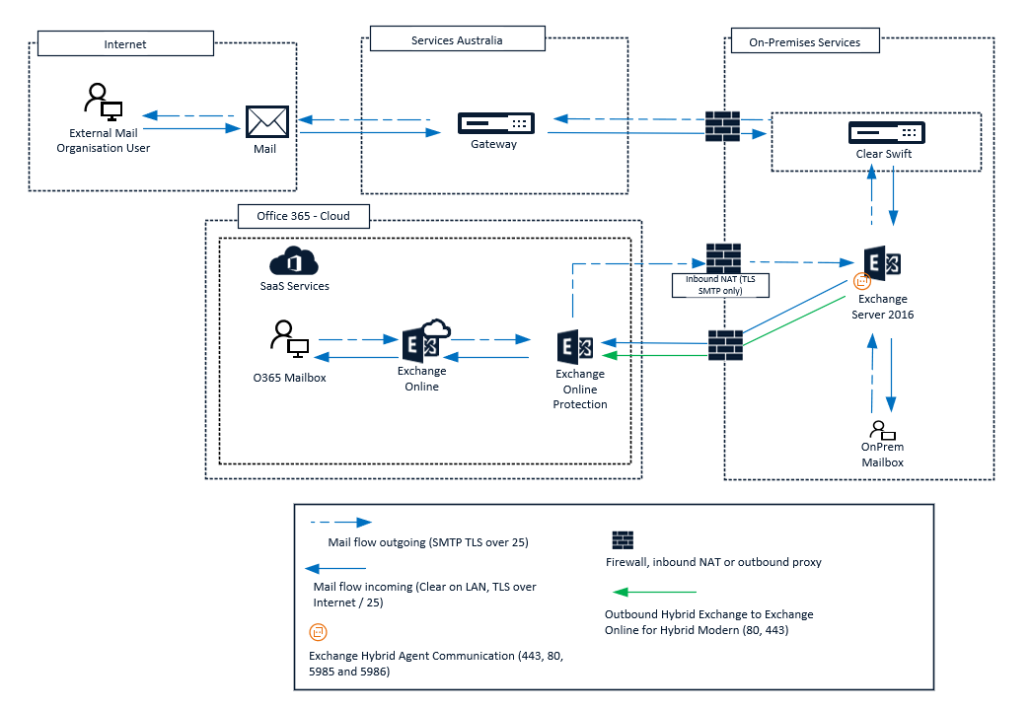
Figure 1 | Proposed SMTP Flow – Hybrid Migration Phase

- Figure 2 below outlines the proposed mail flow and on-premises management configuration to support Hybrid Identity once migration of all mailboxes to Exchange Online is complete.

- 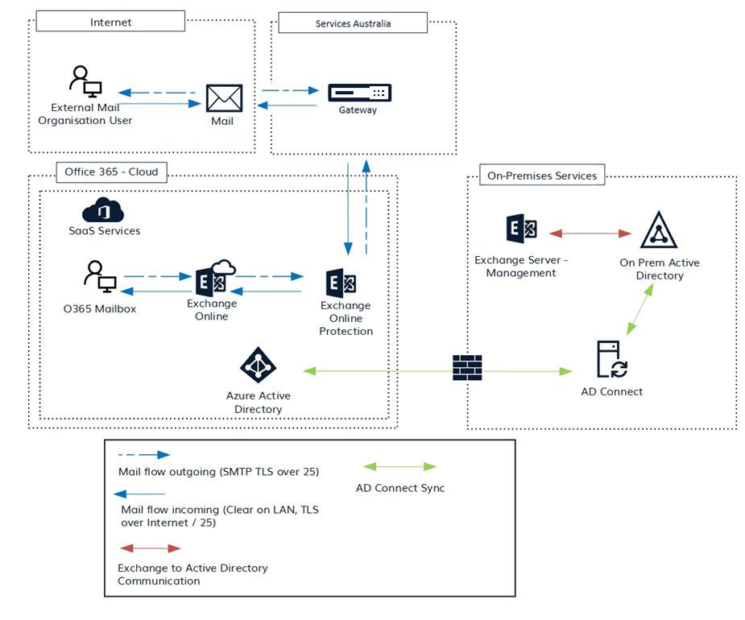
Figure 2 | Proposed SMTP Flow – Post Hybrid Migration

Abbreviations and Acronyms

- Table 7 details the abbreviations and acronyms used throughout this document.
Table 7 | Abbreviations and Acronyms
Acronym | Meaning
DKIM | DomainKeys Identified Mail
DMARC | Domain-based Message Authentication, Reporting and Conformance
DNS | Domain Name System
EOP | Exchange Online Protection
M365 | Microsoft 365
AGENCY | National AGENCY Authority
MX | Mail Exchanger
oobe PL | oobe Pty Ltd
P365 | Perimeta for 365
SMTP | Simple Mail Transfer Protocol
SPF | Sender Policy Framework
TLS | Transport Layer Security

